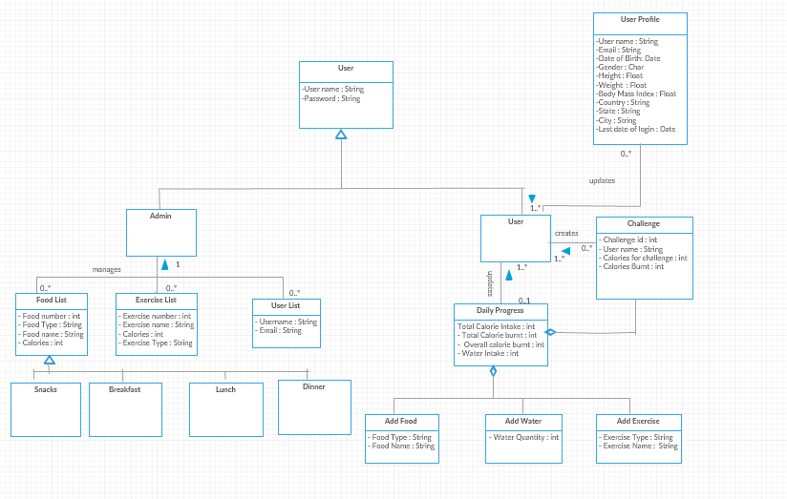

Class names have been changed for add calorie and deleted calorie to add food and add exercise